ITA0610 - Machine Learning
EXP-2
For a given set of training data examples stored in a .CSV file, implement and demonstrate the Candidate-Elimination algorithm in python to output a description of the set of all hypotheses consistent with the training examples
Experiment: Candidate Elimination Algorithm
Aim
To implement and demonstrate the Candidate Elimination Algorithm in Python using a CSV file and obtain the set of all hypotheses that are consistent with the given training examples.
Algorithm
- Import the required Python libraries.
- Read the training dataset from a CSV file.
- Initialize the Specific Hypothesis (S) with the first positive training example.
- Initialize the General Hypothesis (G) with the most general hypothesis.
- For each training example:
  - If the example is Positive (Yes):
    - Update the Specific Hypothesis by generalizing it where necessary.
    - Remove inconsistent hypotheses from the General Hypothesis.
  - If the example is Negative (No):
    - Specialize the General Hypothesis to exclude the negative example.
- Repeat until all training examples are processed.
- Display the final Specific Hypothesis (S) and General Hypothesis (G)
PROGRAM:
import pandas as pd
import numpy as np
data = pd.read_excel("trainingdata.xlsx")
print("Training Data:\n")
print(data)
concepts = np.array(data.iloc[:, :-1])
target = np.array(data.iloc[:, -1])
def learn(concepts, target):
specific_h = concepts[0].copy()
general_h = [["?" for i in range(len(specific_h))]
for j in range(len(specific_h))]
for i, h in enumerate(concepts):
if target[i] == "Yes":
for x in range(len(specific_h)):
if h[x] != specific_h[x]:
specific_h[x] = "?"
general_h[x][x] = "?"
elif target[i] == "No":
for x in range(len(specific_h)):
if h[x] != specific_h[x]:
general_h[x][x] = specific_h[x]
else:
general_h[x][x] = "?"
general_h = [g for g in general_h if g != ["?"] * len(specific_h)]
return specific_h, general_h
specific, general = learn(concepts, target)
print("\nFinal Specific Hypothesis:")
print(specific)
print("\nFinal General Hypothesis:")
for g in general:
print(g)
OUTPUT:
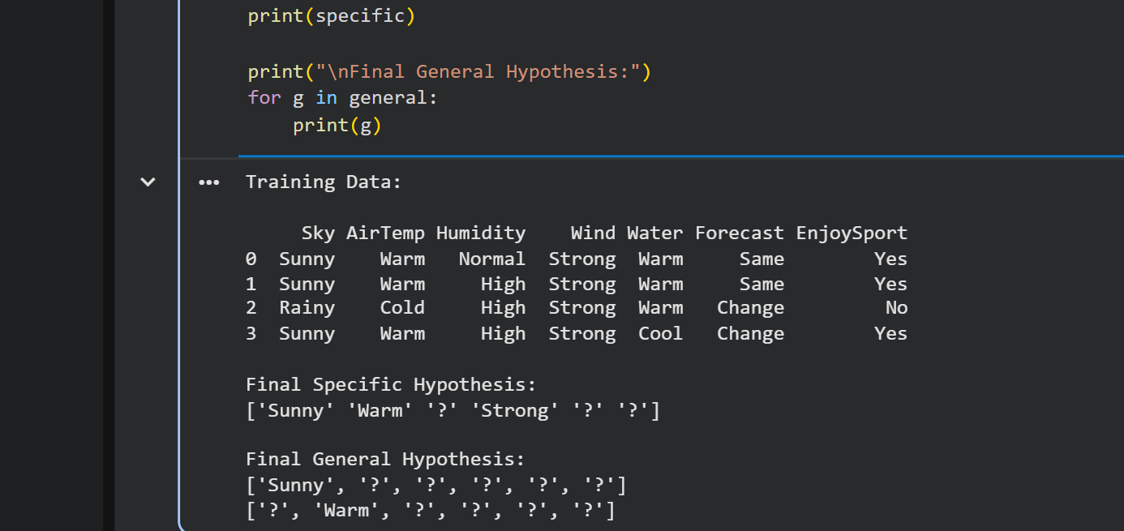

Result
The Candidate Elimination Algorithm was successfully implemented and executed using the given training dataset. The algorithm generated the Specific Hypothesis (S) and General Hypothesis (G), representing the set of all hypotheses consistent with the training examples. The final specific hypothesis obtained was:
['Sunny' 'Warm' '?' 'Strong' '?' '?']
The final general hypotheses obtained were:
['Sunny', '?', '?', '?', '?', '?']
['?', 'Warm', '?', '?', '?', '?']
Hence, the Candidate Elimination algorithm successfully identified the version space consistent with the given training data.

